Exercise notes (trainer)

# Intro

We are a “Fullstack developer”. The Sprint has just started and we have some tasks assigned.

1. There is a BUG when we create Blog Posts, we always have ‘Martin’ as creator. Why?
2. Create an input for us to set the creator Name
3. Only want to see ‘last week’ reports
4. PO wants a report of all the POSTS created by ‘Martin’

# Steps

## Creator is always ‘Martin’

1. Set a breakpoint in “POST” method in the Controller
2. Show data sent by frontend and backend (both are the same)
3. Show we can change data while debugging “Martin Name Changed”
   1. The name ‘Martin’ is clearly coming from the Frontend
   2. Issue is in the Frontend
4. Go to ‘blog-post-add-edit.component.html’ which is the place where we “edit a blog post”
   1. Show how we can change the UI code
      1. Name of button
      2. Color of the button
         1. style="background-color: red;"
      3. Shorter title input
         1. style="width:50%"
5. Go to the TS code
   1. See where ‘Martin’ is set ‘hardcoded’ (you can explain ‘hardcoded’)
   2. Change ‘Martin’ by ‘Jorge’ and see it changes.

## Create an input for ‘creator’

1. Copy&paste title block and change names of variables
   1. See how it renders
   2. When we save there is an “error” in the UI as ‘creator’ still does not exist.
2. Create the variables in TS

formCreator: string;

…

  get creator() { return this.form.get(this.formCreator); }

…

…

this.formCreator = 'creator';

…

creator: ['', [Validators.required]],

* 1. Now we cannot save because ‘Creator’ ‘is required’
     1. Remove the ‘required’ and try to save again
     2. Now we are able to “save” but still with the ‘hardcoded’ creator

1. Create the “write part”
   1. In the ‘Add’ part

creator: this.form.get(this.formCreator).value,

* 1. Cool, we are able to send data!
  2. Now the “Edit” still does not show the “Creator”
     1. Set in the ‘ngOnInit’

this.form.controls[this.formCreator].setValue(data.creator),

* + 1. Now we see the value in the input when ‘Edit’!
    2. But when we save in “Edit” mode it does not stop in the breackpoint
    3. Set a breakpoint in ‘PutBlogPost’
    4. Now see that we are not still receiving the ‘input changed’ in the server
  1. Change the ‘Edit’ part

        creator: this.form.get(this.formCreator).value,

* + 1. We are able to change the ‘Creator’ now

## Last week reports

1. Change ‘GetBlogPosts’ endpoint

.Where(x => x.Dt > DateTime.Now.AddDays(-7))

1. Change ‘Database table’, Date of a Post to show that it’s not visible anymore if we put a further date

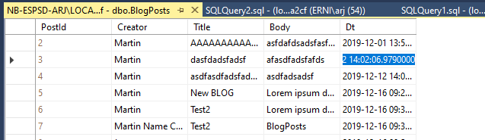

## POSTS created by ‘Martin’

SELECT TOP (1000) [PostId]

,[Creator]

,[Title]

,[Body]

,[Dt]

FROM [BlogPostContext-d08fc301-dc66-44e2-8e02-b408c55da2cf].[dbo].[BlogPosts]

WHERE Creator = 'Martin'

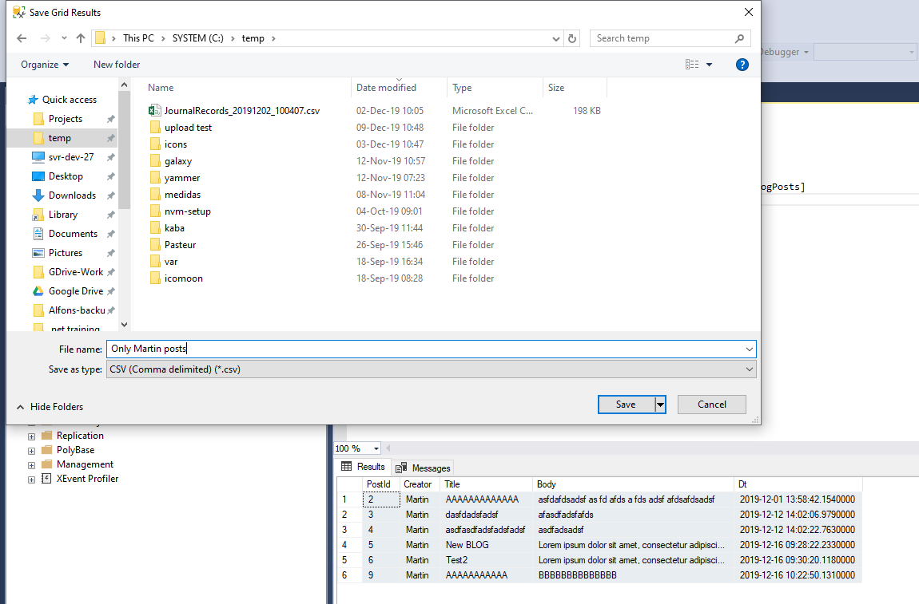

Save as ‘csv’ and open in Excel

Done!